Democratic Senatorial Campaign Committee

**From Wikipedia, the free encyclopedia**

https://en.wikipedia.org/wiki/Democratic%20Senatorial%20Campaign%20Committee  
Licensed under CC BY-SA 3.0:  
https://en.wikipedia.org/wiki/Wikipedia:Text_of_Creative_Commons_Attribution-ShareAlike_3.0_Unported_License

# Democratic Senatorial Campaign Committee

* *It is the only organization solely dedicated to electing Democrats to the United States Senate.*
* *The Democratic Senatorial Campaign Committee (DSCC) is the Democratic Hill committee for the United States Senate.*

The Democratic Senatorial Campaign Committee (DSCC) is the Democratic Hill committee for the United States Senate. It is the only organization solely dedicated to electing Democrats to the United States Senate. The DSCC's current Chair is Senator Catherine Cortez Masto of Nevada, who succeeded Maryland‘s Chris Van Hollen after the 2018 Senate elections. DSCC's current Executive Director is Tom Lopach, who is assisted by Deputy Executive Director Preston Elliott.

# List of Chairs

# Recent history

# 2001–2002 election cycle

* *Her team raised more than $143 million, beating the previous record by $40 million, but Democrats lost two seats.*
* *For the first time since 1914 a President's party had taken control of the Senate in a midterm election.*

Patty Murray became the first female Chair of the DSCC in 2001. Her team raised more than $143 million, beating the previous record by $40 million, but Democrats lost two seats. For the first time since 1914 a President's party had taken control of the Senate in a midterm election. Most observers, though, attributed the outcome to George W. Bush's post-9/11 popularity and the death of Senator Paul Wellstone of Minnesota, who had been favored to win.

# 2005–2006 election cycle

* *However, the party balance for the Senate stood at 51–49 in favor of the Democrats, because independents Bernie Sanders and Joe Lieberman caucused with the Democrats.*
* *Prior to the election, the Republican Party controlled 55 of the 100 Senate seats.*
* *Democrats kept their two open seats in Minnesota and Maryland, and Republicans held onto their lone open seat in Tennessee.*

Chuck Schumer chaired the DSCC for the first of two consecutive cycles. Prior to the election, the Republican Party controlled 55 of the 100 Senate seats. The Senate elections were part of the Democratic sweep of the 2006 elections, in which Democrats made numerous gains and no Congressional or gubernatorial seat held by a Democrat was won by a Republican. Six Republican incumbents were defeated by Democrats: Jim Talent (Missouri) lost to Claire McCaskill, Conrad Burns (Montana) lost to Jon Tester, Mike DeWine (Ohio) lost to Sherrod Brown, Rick Santorum (Pennsylvania) lost to Bob Casey Jr., Lincoln Chafee (Rhode Island) lost to Sheldon Whitehouse, and George Allen (Virginia) lost to Jim Webb. Incumbent Democrat Joe Lieberman (Connecticut) lost the Democratic primary, but won reelection as an independent. Democrats kept their two open seats in Minnesota and Maryland, and Republicans held onto their lone open seat in Tennessee. In Vermont, Bernie Sanders, an independent, was elected to the seat left open by Independent U.S. Senator Jim Jeffords. In the 2006 election, two new female Senators (Claire McCaskill and Amy Klobuchar) were elected to seats previously held by men. This brought the total number of female senators to an all-time high of 16.

Following the elections, no party held a majority of seats for the first time since 1954. However, the party balance for the Senate stood at 51–49 in favor of the Democrats, because independents Bernie Sanders and Joe Lieberman caucused with the Democrats. The Democrats needed 51 seats to control the Senate because Vice President Dick Cheney would have broken any 50–50 tie in favor of the Republicans.

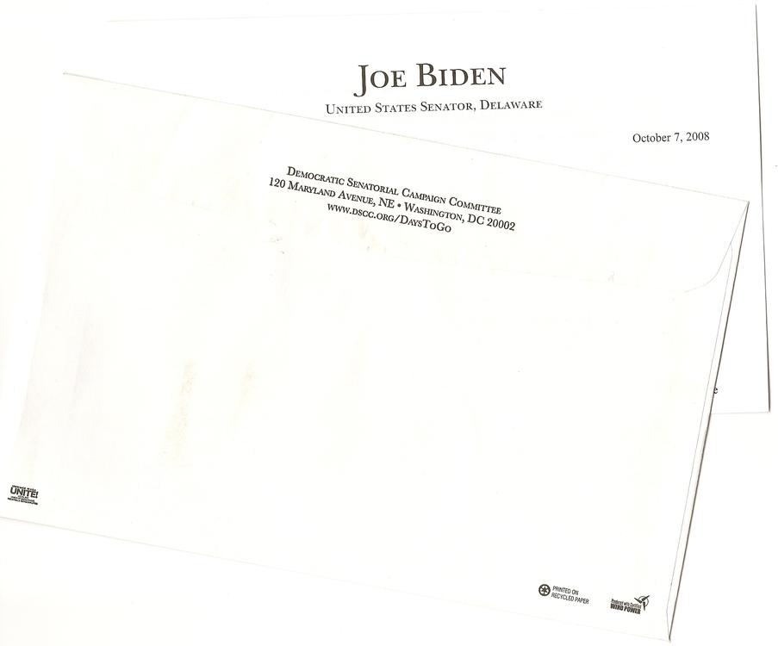  
*DSCC has long focused on direct mail fundraising; here, excerpts from a 2008 example with a plea from U.S. Senator and vice presidential candidate Joe Biden*

# 2007–2008 election cycle

* *This election was the second cycle in a row in which no seats switched from Democratic to Republican.*
* *When the new Senate was first sworn in, the balance was 58–41 in favor of the Democrats, because of the unresolved Senate election in Minnesota.*
* *Of the seats up for election in 2008, 23 were held by Republicans and 12 by Democrats.*

Chuck Schumer chaired the DSCC for the second of two consecutive cycles. Going into the 2008 election, the Senate consisted of 49 Democrats, 49 Republicans, and two independents (Bernie Sanders of Vermont and Joe Lieberman of Connecticut) who caucused with the Democrats, giving the Democratic caucus a 51-49 majority. Of the seats up for election in 2008, 23 were held by Republicans and 12 by Democrats. The Republicans, who openly conceded early on that they wouldn't be able to regain the majority in 2008, lost eight seats. This election was the second cycle in a row in which no seats switched from Democratic to Republican. In addition, this was the largest Democratic Senate gain since 1986, when they also won eight seats.

Democrats defeated five Republican incumbents: Ted Stevens of Alaska lost to Mark Begich, Norm Coleman of Minnesota lost to Al Franken, John Sununu of New Hampshire lost to Jeanne Shaheen, Elizabeth Dole of North Carolina lost to Kay Hagan and Gordon Smith of Oregon lost to Jeff Merkley. Democrats also picked up open seats in Colorado, New Mexico, and Virginia. When the new Senate was first sworn in, the balance was 58–41 in favor of the Democrats, because of the unresolved Senate election in Minnesota. The defection of Republican Arlen Specter of Pennsylvania in April 2009 and the swearing-in of Al Franken of Minnesota in July 2009 brought the balance to 60–40.

# 2011–2012 election cycle

* *In 2012, 23 Democratic Senate seats were available, as opposed to 10 Republican seats.*
* *An increase of four seats would have given the GOP a Senate majority.*
* *In the election, three GOP seats and one Democratic seat was lost, increasing the Democratic majority by two.*
* *The GOP targeted four red states to pick up the seats they need for a Senate majority.*

In 2012, 23 Democratic Senate seats were available, as opposed to 10 Republican seats. An increase of four seats would have given the GOP a Senate majority. In the election, three GOP seats and one Democratic seat was lost, increasing the Democratic majority by two.

DSCC executive director said their strategy was to "localize" elections – make them "a choice between the two people on the ballot...and not simply allow it to be a nationalized election". Because this is not easy to do in a presidential election year, the DSCC had gone very much on the offensive, depicting Republican candidates and donors, and especially the Tea Party, as extreme. During the Florida and Indiana primaries, they pushed that the Tea Party was working to move the GOP "so far to the right that candidates will say anything to get their party's nomination". The GOP targeted four red states to pick up the seats they need for a Senate majority. They were looking at states that did not vote for President Obama in 2008: Missouri, Montana, Nebraska and North Dakota. They lost three of those four seats.

# 2013–2014 election cycle

* *Although Democrats saw some opportunities for pickups, the combination of Democratic retirements and numerous Democratic seats up for election in swing states and red states gave Republicans hopes of taking control of the Senate.*
* *7 of the 21 states with Democratic seats up for election in 2014 had voted for Republican Mitt Romney in the 2012 presidential election.*

In 2013, 21 Democrats were up for either reelection or election to complete the six-year term. In order to have a majority, the Republicans were required to attain at least 51 seats in the Senate. The Democrats would have been able to retain a majority with 48 seats (assuming the two Independents continued to caucus with them) because, in event of a tie vote, Vice President Joe Biden becomes the tie-breaker. Many of the incumbents were elected in the Democratic wave year of 2008 along with President Obama's first election.

Although Democrats saw some opportunities for pickups, the combination of Democratic retirements and numerous Democratic seats up for election in swing states and red states gave Republicans hopes of taking control of the Senate. 7 of the 21 states with Democratic seats up for election in 2014 had voted for Republican Mitt Romney in the 2012 presidential election. Democrats also faced the lower voter turnout that accompanies mid-term elections.

By midnight ET, most major networks projected that the Republicans would take control of the Senate. The party held all three competitive Republican-held seats (Kentucky, Kansas, and Georgia), and defeated incumbent Democrats in North Carolina, Colorado, and Arkansas. Combined with the pick-ups of open seats in Iowa, Montana, South Dakota, and West Virginia, the Republicans made a net gain of 7 seats before the end of the night. In the process of taking control of the Senate, Republicans defeated three incumbent Democrats, a task the party had not accomplished since the 1980 election. Five of the seven confirmed pickups were in states that voted for Mitt Romney in 2012, but two of the seats that Republicans won represent states that voted for Barack Obama in 2012 (Colorado and Iowa). Of the three races that were not called by the end of election night, Alaska and Virginia were still too close to call, while Louisiana held a December 6 run-off election. Virginia declared Democrat Mark Warner the winner of his race by a narrow margin over Republican Ed Gillespie on November 7, and Alaska declared Dan Sullivan the winner against Democratic incumbent Mark Begich a week later, on November 12. Republican Bill Cassidy defeated Democratic incumbent Mary Landrieu in the Louisiana runoff on December 6.

Days after the election, the United States Election Project estimated that 36.6% of eligible voters voted, 4% lower than the 2010 elections, and possibly the lowest turnout rate since the 1942 election.

# 2015–2016 election cycle

* *This was the first time since 1992 that the Democrats gained seats in this Senate Class.*
* *After the election, Democrats gained only two seats.*
* *The Democrats needed to gain 4 seats as the Republicans held the majority 54-46, with both independent candidates caucusing with the Democrats.*
* *Democrats had ten seats where women were the nominee with only one being an incumbent while Republicans had two seats where women were the nominee and both were incumbents.*

In 2015 10 Democrats and 23 Republicans were up for either reelection or election to complete the six-year term. In order to have gained a majority, the Democrats would have needed to attain at least 51 seats or 50 seats (and hold the presidency) in the Senate. If they had won the presidency, the Democrats would have been able to gain a majority with 48 seats (assuming the two Independents continued to caucus with them) because, in event of a tie vote, the Vice President becomes the tie-breaker. Many of the incumbents were elected in the Republican wave year of 2010 midterm. The Democrats needed to gain 4 seats as the Republicans held the majority 54-46, with both independent candidates caucusing with the Democrats. Two-term Senator Jon Tester of Montana chaired the DSCC for this cycle.

There were five seats that the Democrats needed to defend this cycle: Michael Bennet of Colorado, Patty Murray of Washington, and the seats of retiring Senators Harry Reid, Barbra Boxer and Barbara Mikulski. Seven of the Republican seats that were up for reelection were in states that Obama won twice, Senator Mark Kirk of Illinois, Senator Pat Toomey of Pennsylvania, Senator Ron Johnson of Wisconsin, Senator Kelly Ayotte of New Hampshire, Senator Chuck Grassley of Iowa, Senator Rob Portman of Ohio and Senator Marco Rubio of Florida who ran for reelection after an unsuccessful presidential bid. In all but one of those seats, Iowa, the Republican incumbents were fighting to be reelected for the first time. Democrats were also targeting the open seat in Indiana which was vacated by the retiring Senator Dan Coats. There were several other states the Democrats were focused on where the Republican incumbents may have been vulnerable: Senator John McCain of Arizona, Senator Lisa Murkowski of Alaska, Senator John Boozman of Arkansas, Senator Richard Burr of North Carolina, Senator Johnny Isakson of Georgia, Senator Roy Blunt of Missouri, Senator Rand Paul of Kentucky who simultaneously ran for President, and Senator David Vitter of Louisiana.

Democrats had ten seats where women were the nominee with only one being an incumbent while Republicans had two seats where women were the nominee and both were incumbents.

After the election, Democrats gained only two seats. Tammy Duckworth of Illinois and Maggie Hassan of New Hampshire joined the caucus. They also successfully defended their only seat in contention, Nevada where Catherine Cortez Masto became the first Latina U.S. Senator. This was the first time since 1992 that the Democrats gained seats in this Senate Class. For the first time the DSCC did not endorse a candidate in the general election in California because both women were Democrats competing for retiring Senator Barbara Boxer. Kamala Harris beat Loretta Sanchez for the seat.

# 2017–2018 election cycle

* *One-term Senator Chris Van Hollen from Maryland chairs the DSCC for the 2017–2018 election cycle.*
* *The unusually imbalanced 2018 Senate map, created by successful 2006 and 2012 elections, has resulted in a large number of vulnerable Democrats.*
* *Before the 2018 elections, Democrats hold 49 seats in the U.S. Senate while Republicans hold 51.*
* *On November 6, incumbent Democrats in four states were unseated.*

One-term Senator Chris Van Hollen from Maryland chairs the DSCC for the 2017–2018 election cycle. Before the 2018 elections, Democrats hold 49 seats in the U.S. Senate while Republicans hold 51. The unusually imbalanced 2018 Senate map, created by successful 2006 and 2012 elections, has resulted in a large number of vulnerable Democrats. Joe Donnelly of Indiana, Claire McCaskill of Missouri, Joe Manchin of West Virginia, Heidi Heitkamp of North Dakota, Jon Tester of Montana and Bill Nelson of Florida are seen as most vulnerable. On November 6, incumbent Democrats in four states were unseated. Senator Donnelly was unseated by State Rep. Mike Braun, Sen. McCaskill was defeated by Missouri Attorney General Josh Hawley, Sen. Heitkamp was defeated by Kevin Cramer, representative for North Dakota's at-large congressional district, and long term Sen. Nelson was defeated by then governor Rick Scott. The DSCC considered open seats in Arizona and Tennessee, Dean Heller's seat in Nevada and potentially Ted Cruz's seat in Texas and Cindy Hyde-Smith's seat in Mississippi as possible targets. Of those potentially vulnerable seats, Democrats picked up the open seat in Arizona vacated by Jeff Flake, with Rep. Kyrsten Sinema defeating Rep. Martha McSally, as well as the seat in Nevada held by Dean Heller, being defeated by Rep. Jacky Rosen, leaving the Senate's balance at 53-47, with Republicans in control.

# See also

* *National Republican Senatorial Committee*
* *Democratic Congressional Campaign Committee*

Democratic Congressional Campaign Committee

National Republican Senatorial Committee

Green Senatorial Campaign Committee

# References

# External links

* *Official website*

Official website